What is the role of the Patient Participation Group (PPG)?
The PPG are a group of patients who meet, together with health professionals to ensure that patients are given a ‘voice’ within the GP practice. It is the PPG’s responsibility is to ensure that plans, services and activities respond to patient’s priorities and needs and to act as a critical friend to the Practice. The PPG does not discuss any patient’s personal health details.
Where and when do we meet?
The meetings take place on the first Tuesday morning of the month, on ten occasions per year. Subgroups formed from a few PPG members meet more frequently when working on specific projects.
Examples of work completed to date
- Developing and completing annual patient surveys
- Planning health awareness weeks, held at the surgery which included co-ordinating a range of health specialists and speakers
- Assisting in obtaining patient feedback to aid the planning of health services
- Developing and arranging the display of Health promotion materials and campaigns for the Practice Patient Waiting room.
- Supporting the practice with the Covid & Flu Campaign

Getting involved
Would you like to join the Moorland Medical Centre PPG?
Join us as an active volunteer and use your personal experiences to contribute to the planning of local primary healthcare services. Every member’s contribution is valued and appreciated. It is essential that all information is kept strictly confidential; you would therefore be required to sign a confidentiality agreement prior to starting.

Joining the PPG
Email us at: moorland.med@nhs.net
Telephone us on 01538 399008
Or
Pop in to the practice and request a contact application form, please return it to the practice when you have completed it.
Visit the Moorland Medical Centre website at www.moorlandmedicalcentre.co.uk and follow the links under the section ‘Have your say’.

Useful Contacts
Royal Stoke University Hospital 01782 715444
Leek Moorlands Hospital 0300 123 1894
Douglas Macmillan Hospice 01782 344300
Staffordshire Social Care 0300 1118010
Citizens Advice Bureau 0808 2787876 or www.snscab.org.uk
The Carers Hub 0330 123 1937
Minor Injuries Unit
Leek Moorlands Hospital, Ashbourne Road, Leek, Staffordshire, ST13 5BQ. Tel: 0300 123 1894
The Minor Injuries Unit is a nurse led service which provides treatment for minor illness and injury including wounds needing stiches, rashes, ear infections, sprains and strain, suspected broken limbs, bites and stings, minor head injuries, minor burns, sore throats and foreign bodies in the eye.
Leek Minor Injuries Unit Current opening hours: 9am – 5pm (last admission to the unit is 4.30pm). Walk in service - no appointment or booking required
Walk in Centres
Haywood Hospital, High Lane, Burslem, Stoke-on-Trent, Staffordshire, ST6 7AG. Tel: 01782 673500
The Walk-in Centre at Haywood Hospital will be able to provide these essential services. Orthopaedic surgeons and emergency nurse practitioners from Royal Stoke will join the Haywood Walk-in Centre team to provide an enhanced service. You do not need an appointment, but you can use the NHS 111 website and they will be able to book one for you. The Walk-in Centre is open from 7:00am to 9:30pm every day.
Call NHS 111 if GP surgery is closed and you need urgent medical help or advice but it is not life threatening or are unsure which service you require
Call 999 for critical or life threatening situations.

Moorland Medical Centre
Patient Participation Group

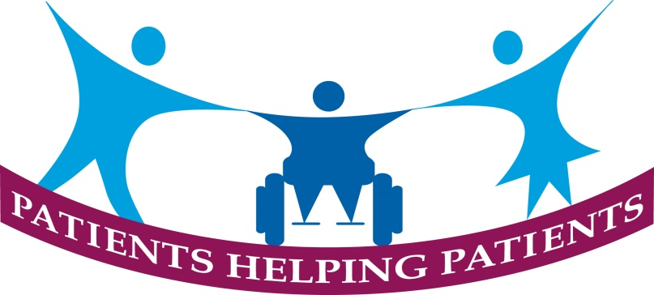

Moorland Medical Centre
Dyson House
Regent Street
Leek, Staffordshire
ST13 6LU
Telephone: 01538 399008
Email:moorland.med@nhs.net www.moorlandmedicalcentre.co.uk

